Nagel Point

Note – if reading the description/motivation for this problem is confusing, I apologize, but I believe that you can still complete this problem if you were to only read the method description.

From Wikipedia, the free encyclopedia, in geometry, an excircle of a triangle is a circle lying outside the triangle, tangent to one of its sides and tangent to the extensions of the other two sides. Every triangle has three distinct excircles, each tangent to one of the triangle's sides. In the diagram below, J_{A}, J_{B} and J_{C} are the center of the three excircles

The Nagel Point is a point associated with any triangle. In the plane of a triangle ABC with side lengths a = |BC|, b = |CA|, and c = |AB|, let Ta, Tb, and Tc be the points in which the J_{A}- excircle meets line BC, the J_{B}-excircle meets line CA, and J_{C}-excircle meets line AB, respectively. The lines ATa, BTb, CTc concur in the Nagel point N of triangle ABC. The Nagel point is named after Christian Heinrich von Nagel, a nineteenth century German mathematician.
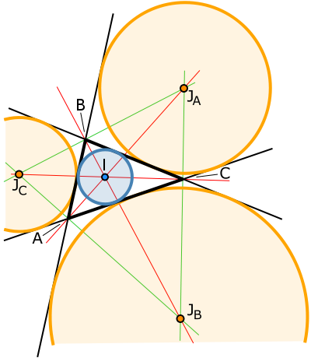

Another construction of the Nagel Point is to start at the vertex of A and trace around triangle ABC half its perimeter to the point Ta, and similarly for Tb and Tc.

The Nagel Point is now found by finding the intersection of the line segments connecting points A and Ta and the line segment connecting B and Tb and the line segment connecting C and Tc.

To complete this program you have been supplied with the following Point class:

public class Point {
private double x;
private double y;

/**
* Constructor for objects of class Point
*/
public Point(double a, double b) {
x = a;
y = b;
}

public double getX() { return x; }

public double getY() { return y; }

public boolean equals(Object obj) {
Point temp = (Point) obj;

return Math.abs(x - temp.getX()) < 0.002
&& Math.abs(y - temp.getY() ) < 0.002;
}

public int hashCode() {
Integer t = new Integer((int)( x * y)) ;
return t.hashCode();
}
}

Your task in this problem is to complete the four methods in the NagelPoint class below.

public class NagelPoint
{
private Point x, y, z;
public NagelPoint(Point a, Point b, Point c)
{
x = a;
y = b;
z = c;
}

/*
* return perimeter of triangle determine by the 3 points x, y and z
*/
public double getPerimeter() { return -1; }

/*
* return the Bisected Perimeter Point
* First calculate perimeter of triangle determine by v, w and t
* trace the triangle from point v to w and then towards t.
* The bisected perimeter point is arrived at after tracing half
* the perimeter.
*/
public Point getBisectedPerimeterPoint(Point v, Point w, Point t)
{
return new Point(-1, -1);
}

/*
* return Point of intersection between the line containing
* the points x1 and x2 and
* the line containing the points y1 and y2
*/
public Point getIntersection(Point x1, Point x2, Point y1, Point y2)
{
return new Point(-1, -1);
}

/*
* return Point of intersection between the line containing any two of
* the three lines containing the points:
* x and the bisected perimeter point found starting at x.
* y and the bisected perimeter point found starting at y.
* or z and the bisected perimeter point found starting at z.
*/
public Point getNagelPoint()
{
return new Point(-1, -1);
}
}

A sample run of this program is as follows:

Point x = new Point(0, 0);
Point y = new Point(8, 0);
Point z = new Point(8, 6);
NagelPoint np = new NagelPoint( x, y, z);

np.getPerimeter() // returns 24
np.getBisectedPerimeterPoint(x, y, z) // returns the point (8, 4)
np.getBisectedPerimeterPoint(y, z, x) // returns the point (3.2, 2.4)
np. getNagelPoint() // returns the point (2, 4)

